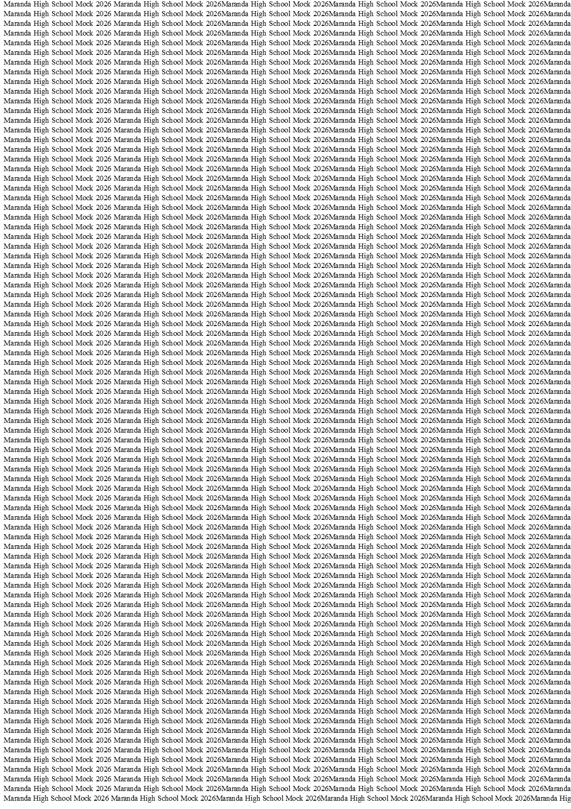



MARANDA HIGH SCHOOL
Kenya Certificate of Secondary Education
THE MOCK EXAMINATIONS, 2026
313/1 CRE PAPER 1

May/June 2026 Time: 2½ Hours

Name: …………………………………….……. Admission No:…………
Stream: ………….. Signature: ……...... Wednesday, 3rd June, 2026; 2:00-4.30pm
Instructions
- Write your name and index number in the spaces provided above.
- Sign and write the date in the space provided above.
- This paper contains SIX Questions.
- Answer any five questions in the spaces provided.
- Each question carries 20 marks.
- This paper consists of 14 printed pages
- Candidates should check the question paper to ascertain that all pages are printed as indicated and no question are missing.
- Candidates should answer the questions in English.
FOR EXAMINERS’USE ONLY

FOR EXAMINERS ONLY.
QUESTION |  |  |  |  |  | TOTAL SCORE
CANDIDATE’S
SCORE

© 2026 The Maranda School
313/1 Turn Over
- a) State six reasons why the Bible is referred to as a library of books. (6 marks)
b) Outline the efforts made by God to restore the damaged relationship between Him and man after the fall of man. (7 marks)
c) There are many ways of disciplining people in society today. In this regard, identify seven ways through which the church punishes the errant members in the church today.
(7 marks)
- a) Identify the events that took place on the eve of the Passover in Exodus 12:29-32
(6 marks)
b) Give seven reasons why Christians are commanded not to steal. (7 marks)
c) What lessons do church leaders learn from the leadership of Moses? (7 marks)
- a) State six reasons for kingship in Israel. (6 marks)
b) Explain the significance of David as an ancestor of Jesus to Christians today. (8 marks)
c) State six lessons that Christians learn from the failures of King Saul. (6 marks)
- a) State six categories of true prophets in the Old Testament. (6 marks)
b) Identify seven ways in which the rich oppressed the poor during the time of Amos.
(7 marks)
c) State seven reasons why Christians should repent their sins. (7 marks)
- a) Explain six symbolic acts used by Prophet Jeremiah to demonstrate God’s judgement and punishment to the Israelites. (6 marks)
b) Outline seven teachings of Prophet Jeremiah on the new covenant in Jeremiah
31:31-34 (7 marks)
c) Identify seven ways used by the church leaders in Kenya to communicate God’s message to the people. (7 marks)
- a) Describe the traditional African concepts of a community. (7 marks)
b) Outline the role African cultural practices that have been integrated in a Christian worship today. (7 marks)
c) Identify six ways in which the church in Kenya is assisting orphans in the society today. (6 marks)
….…………………………………………………………………………………………………..….…………………………………………………………………………………………………..………………………………………………………………………………………………………………………………………………………………………………………………………………………………………………………………………………………………………………………………………………………………………………………………………………………………………………………………………………………………………………………………………………………………………………………………………………………………………………………………………………………………………………………………………………………………………………………………………………………………………………………………………………………………………………………………………………………………………………………………………………………………………………………………………………………………………………………………………………………………………………………………………………………………………………………………………………………………………………………………………………………………………………………………………………………………………………………………………………………………………………………………………………………………………………………………………………………………………………………………………………………………………………………………………………………………………………………………………………………………………………………………………………………………………………………………………………………………………………………………………………………………………………………
….…………………………………………………………………………………………………..….…………………………………………………………………………………………………..………………………………………………………………………………………………………………………………………………………………………………………………………………………………………………………………………………………………………………………………………………………………………………………………………………………………………………………………………………………………………………………………………………………………………………………………………………………………………………………………………………………………………………………………………………………………………………………………………………………………………………………………………………………………………………………………………………………………………………………………………………………………………………………………………………………………………………………………………………………………………………………………………………………………………………………………………………………………………………………………………………………………………………………………………………………………………………………………………………………………………………………………………………………………………………………………………………………………………………………………………………………………………………………………………………………………………………………………………………………………………………………………………………………………………………………………………………………………………………………………………………………………………………………….…………………………………………………………………………………………………..….…………………………………………………………………………………………………..………………………………………………………………………………………………………………………………………………………………………………………………………………………………………………………………………………………………………………………………………………………………………………………………………………………………………………………………………………………………………………………………………………………………………………………………………………………………………………………………………………………………………………………………………………………………………………………………………………………………………………………………………………………………………………………………………………………………………………………………………………………………………………………………………………………………………………………………………………………………………………………………………………………………………………………………………………………………………………………………………………………………………………………………………………………………………………………………………………………………………………………………………………………………………………………………………………………………………………………………………………………………………………………………………………………………………………………………………………………………………………………………………………………………………………………………………………………………………………………………………………………………………………………….…………………………………………………………………………………………………..….…………………………………………………………………………………………………..………………………………………………………………………………………………………………………………………………………………………………………………………………………………………………………………………………………………………………………………………………………………………………………………………………………………………………………………………………………………………………………………………………………………………………………………………………………………………………………………………………………………………………………………………………………………………………………………………………………………………………………………………………………………………………………………………………………………………………………………………………………………………………………………………………………………………………………………………………………………………………………………………………………………………………………………………………………………………………………………………………………………………………………………………………………………………………………………………………………………………………………………………………………………………………………………………………………………………………………………………………………………………………………………………………………………………………………………………………………………………………………………………………………………………………………………………………………………………………………………………………………………………………………….…………………………………………………………………………………………………..….…………………………………………………………………………………………………..………………………………………………………………………………………………………………………………………………………………………………………………………………………………………………………………………………………………………………………………………………………………………………………………………………………………………………………………………………………………………………………………………………………………………………………………………………………………………………………………………………………………………………………………………………………………………………………………………………………………………………………………………………………………………………………………………………………………………………………………………………………………………………………………………………………………………………………………………………………………………………………………………………………………………………………………………………………………………………………………………………………………………………………………………………………………………………………………………………………………………………………………………………………………………………………………………………………………………………………………………………………………………………………………………………………………………………………………………………………………………………………………………………………………………………………………………………………………………………………………………………………………………………………….…………………………………………………………………………………………………..….…………………………………………………………………………………………………..………………………………………………………………………………………………………………………………………………………………………………………………………………………………………………………………………………………………………………………………………………………………………………………………………………………………………………………………………………………………………………………………………………………………………………………………………………………………………………………………………………………………………………………………………………………………………………………………………………………………………………………………………………………………………………………………………………………………………………………………………………………………………………………………………………………………………………………………………………………………………………………………………………………………………………………………………………………………………………………………………………………………………………………………………………………………………………………………………………………………………………………………………………………………………………………………………………………………………………………………………………………………………………………………………………………………………………………………………………………………………………………………………………………………………………………………………………………………………………………………………………………………………………………….…………………………………………………………………………………………………..….…………………………………………………………………………………………………..………………………………………………………………………………………………………………………………………………………………………………………………………………………………………………………………………………………………………………………………………………………………………………………………………………………………………………………………………………………………………………………………………………………………………………………………………………………………………………………………………………………………………………………………………………………………………………………………………………………………………………………………………………………………………………………………………………………………………………………………………………………………………………………………………………

